Product Warning and Recall

Liquid gas cookers and replacement assemblies of liquid gas cookers
from Dometic
- Leaking cooker gas tubes and gas regulators -
Risk of serious injury!

Please be informed of the following voluntary product recall from the market.

The following products are affected by the voluntary recall:

SKU | Description | Family
9600027605 | Dometic PI8022 EU | cooktop
9600027606 | Dometic PI8022 12V ignition AM | cooktop
9600027608 | Dometic PI8023 AM | cooktop
9600037309 | Dometic CE99-ZF AM | cooktop
9600037310 | Dometic CE99-ZF OEM | cooktop
9600037313 | Dometic CE99-DF AM | cooktop
9600037315 | Dometic KSK2007R | cooktop
9600037317 | Dometic PI9003 | cooktop
9600037319 | Dometic MO9722R Piezo | combination
9600037320 | Dometic MO9722L Piezo | combination
9600037321 | Dometic MO9722R AM | combination
9600037322 | Dometic MO9722L AM | combination
9600037324 | Dometic MO9222R | combination
9600037325 | Dometic MO9222L | combination

You can also refer to the operating instructions for your vehicle for the precise product description of the cooker installed in your vehicle.

Photos of the affected cookers are given below by way of example:

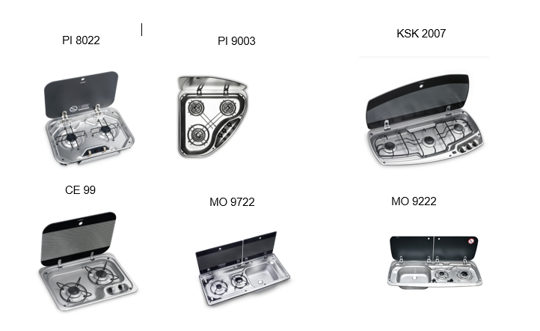

The background to this decision is information concerning a potential leakage of the assemblies installed in cookers (cooker regulators and/or supply tubes).
Should the product be subject to leakage, an undetermined amount of gas can leak, which where a suitable ignition source is present, may ignite. As a result of this, a flame formation can occur around the regulators. Furthermore, in worst case scenarios there is the potential for the gas-air mixture to explode. This can result in serious injury to the user of our products and uninvolved third parties

To date we are not aware of any incident in the field where an injury has occurred.

Should you have purchased one of the above-mentioned products, please stop using the product immediately, close the shut-off valve and keep it closed!

Instructions on how to close the shut-off valve properly are given below:

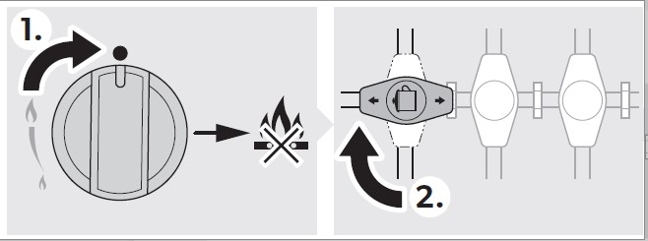

The manufacturer is working intensively on a solution and we will contact you as soon as possible with the resolution.
.

If you have any further questions, please contact your supplier

We apologise for the inconvenience and expressly thank you for your understanding.

